TSL Tutor – Structure

**© Anar Kazimov and Software Gates Team, 2016**

This document contains information about the structure of the Turkish Sign Language tutor app. It is aimed to programmists in order to create a smooth transition to the project for them. We insist on you reading the “TSL Working Principle” before reading this document.

# The root folder.

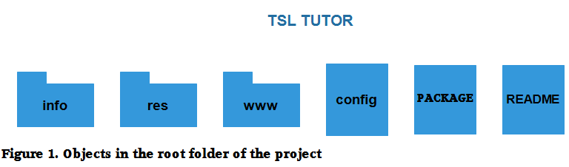

* INFO – this folder contain all information about our project – structure, aims and also include the current document.
* README - this is just a brief description of the project that will be shown on GitHub.
* res – this folder contains icons and splash images.
* www – this is our main folder containing all source codes, images and audios used by the app.
* Config – this document contains a vital data for our web 🡪 apk/ipa/exe builder called Phonegap.
* Package - has a brief information about our app to be used by Phonegap.

# If you have just started working on the app you don’t need to think about any other folder but the www folder.

# The www folder

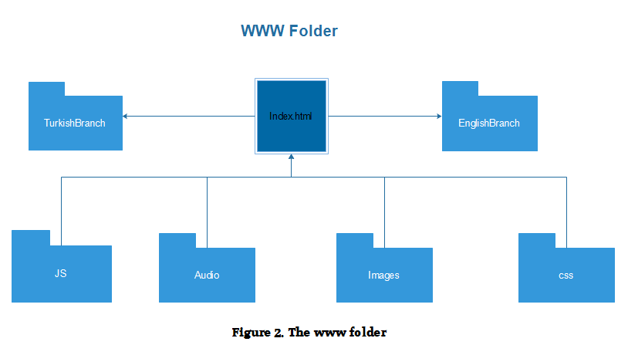

Index.html file is the main file of the app. When user opens the application for a first time he asked for his preferable language and afterwards directed either to the TurkishBranch folder or the EnglishBranch folder. When user will open the app for a second time he won’t be asked to choose a language anymore and will be redirected automatically. However user will always be able to move to the language page if required just as illustrated in Figure 3,

